* **SQL Revision  
  questions of the session**consider the following schema:  
  STUDENTS ( student_code ,first_name , last_name , email , phone_no , date_of_birth , graduation_project , percentage_of_marks )  
  🡪 write a query to ::
* **Display the distinct graduation project in the given table.  
    
  select distinct / unique graduation_project from students;**
* **Display all students where the 2nd letter in the 1st name is [i]   
    
  select * from students where first_name like ‘_i%’;**
* **Display names of all the students whose email are not provided  
    
  select first_name || ‘ ‘ || last_name “student name”  
  from students  
  where email is null;**
* **Display names of all students in desc order of percentage of marks  
    
  select first_name || ‘ ‘ || last_name “student name”,percentage_of_mark  
  from students  
  order by percentage_of_mark desc ;**
* **List the avg percentage of marks in each graduation project, when the avg is > 50 %  
    
  select avg(percentage_of_marks), graduation_project  
  from students  
  group by graduation_project  
  having avg(percentage_of_marks) > 50 ;  
   > 0.50;  
  طيب عملناها 50 مرة ومرة 0.50 ليه   
  لأننا مش عارفين نتأكد من شكل القيم بتاعة العمود بتاع النسب  
  متنساش الملحوظة دي مع ال   
  group by  
  لو العمود موجود مع ال  
  group by   
  من البداية  
  إذن عادي أحطه في ال   
  select   
  وعادي محطوش  
  بينماااااااااااااااااا  
  لو كان هو أصلا موجود في ال  
  select   
  ومعلهوش   
  aggregate function  
  بداية .. من غير ما يكون مع جملة ال  
  group by  
  فهو دا ميصحش لأنه بيؤدي لاختلاف في أطوال الأعمدة أثناء العرض وبيعمل ايرور  
  والصحيح في الحالة دي تضمينه بداخل جملة ال   
  group by   
  هي كمان مع ال   
  select**

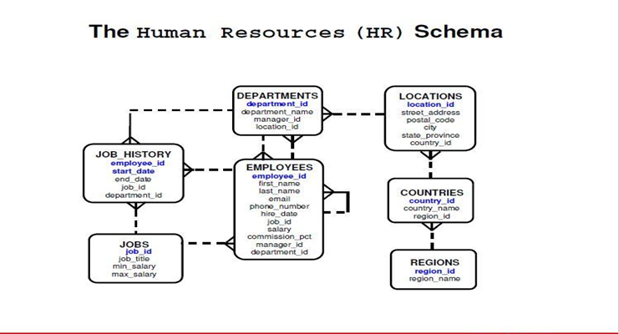

**Display the employees' full name for employees who work for department number 20 in two-ways.  
هتعمل ب  
||  
ومرة تانية ب  
concat()**

 **Display the employees' numbers and salary for all employees whose salary is not in the range of $3500 and $5000.  
  
select employee_id, salary   
from employees  
where salary not between 3500 and 5000;  
لو عكست الرقمين فقط >> هيعتبر السطر الأخير لاغي  
لكن لو عكست ومعاها شلت ال   
not  
مش هيعرض حاجة  
ومينفعش تعمل الأقواس دي**





**Display the full data for all employees who earn commissions.  
select * from employees where commission_pct is not null;**

**Display the name, job and salary for all employees  
whose job ends with** REP **or** PROG **and their salary is equal to $1000, $3000 or $5000**

select first_name||’ ‘||last_name full_name, job_id, salary

from employees

where (job_id like ‘%REP’ or job_id like ‘%PROG’)   
and salary in (1000,3000,5000);

**لاحظ الأقواااااااااااااااااااااااااااااس جنب ال   
where**

**Display all information about employees whose last name doesn't begin with letter 'S'.**

**select * from employees where last_name not like ‘S%’;**

**Display the employees Id, name who earns more than 3000 LE monthly.  
  
select employee_id, first_name   
from employees  
where salary > 3000;**

**Display the employees Id, name who earns more than 28000 LE annually.  
  
select employee_id, first_name  
from employees  
where salary*12 > 2800;**

1. **Display the Departments full data whose name starts with "M" letter.  
     
   select *   
   from departments  
   where department_name is like ‘M%’;**

**Display all the employees in department 30 whose salary from 10000 to 20000 LE monthly.  
  
select *   
from employees  
where salary between 10000 and 20000 and department_id =30;**

 **Display**

**the difference between the highest and lowest salaries**

**in each department**

**only display the difference if it’s greater than 2000  
  
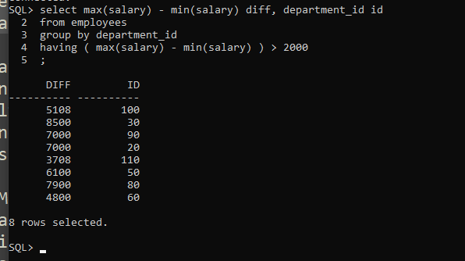**

**Display the average salary for each job in each department.**

**select department_id, job_id, avg(salary)**

**from employees**

**group by department_id, job_id;**

**#still  
Display the**

**no. of departments**

**which their summation of salaries between 15000 and 20000**

**and display the result in descending order.**

**select count(department_id)**

**from employees**

**order by**

**Display the no. of employees in the department that you will enter its name at run-time.  
  
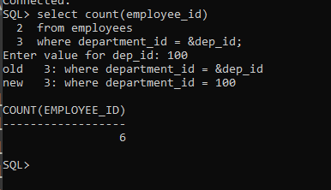  
  
  
Display the summation of salaries for all employees**

**whom first name doesn't starts with 'S' letter  
  
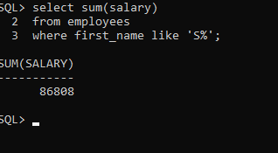**

 **#still**

**Display the Managers' full name and their salaries {in two-ways}**

**1]  
 self-join**

**select m.first_name ||' ' || m.last_name , m.salary**

**from**

**2]**

 **#still  
For each department,   
display department name, department number   
and number of employees.**